REGISTRATION PROCESS - ON BEHALF OF BUSINESS
Step 1: Go to https://kansascommerce.my.site.com/Grants/s/
Step 2: If you already have an account, IGNORE and login to the portal using your credentials. Otherwise, want to start your new registration just click “Need to Register?” which is under the login button.
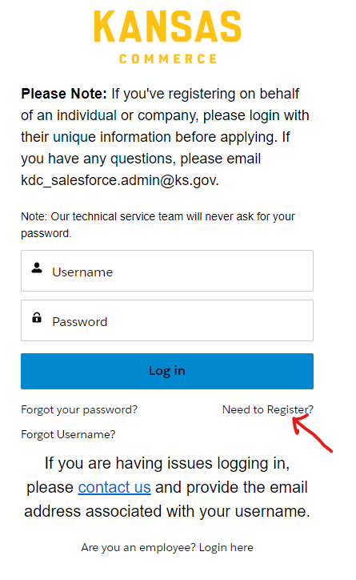
Step 3: After you see the Registration Page, just click on the Registration button, and follow the instructions that are mentioned on the registration page.
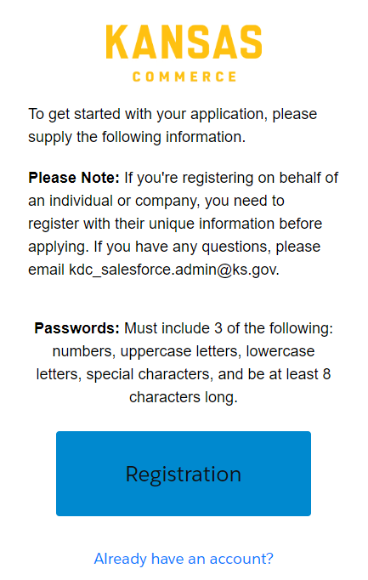
Step 4: Next, fill out all the details that are required (*) in the create account page and make sure when you are filling Applying on behalf of? (Referring to Business) – if you are applying on behalf of a Business or County or City or Foundation.
Note: Business (or) County (or) City (or) Foundation refers to business E-mail or work E-mail from that business domain.
After filling in all the details click Next which you can find in the bottom–right corner of Create Account page.
Note: Don’t close the window, please wait till the page loads.
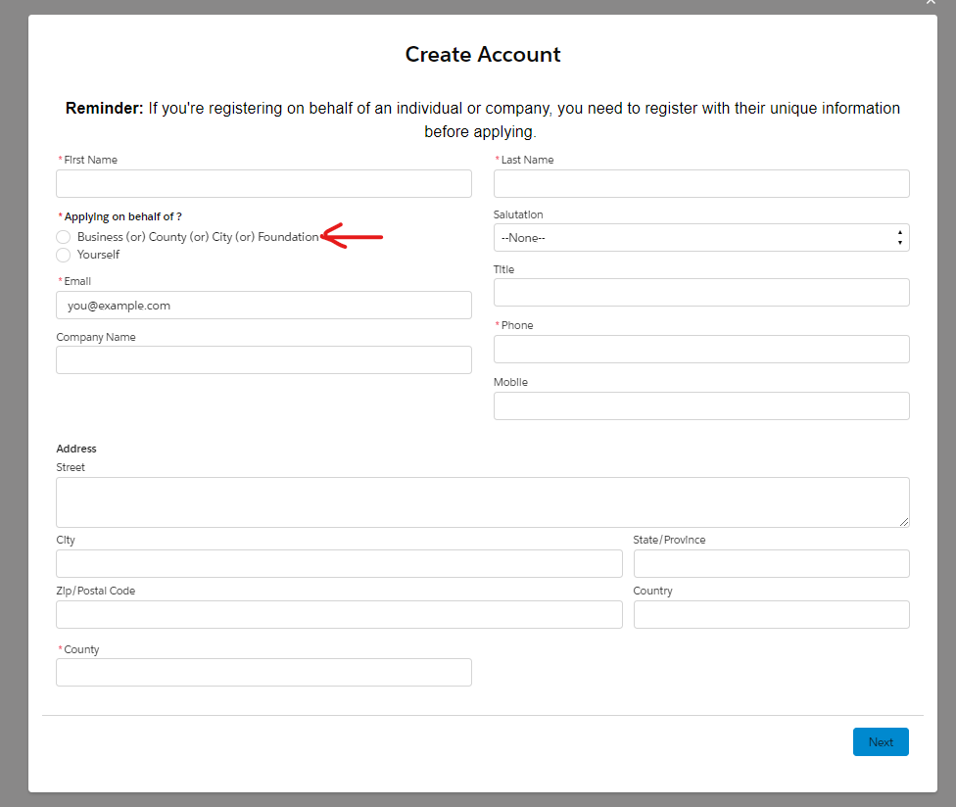
Step 5: If the registration is successful, you will receive an E-mail for setting up the password and the screen pops up saying “Your account is created successfully”. Then click Finish to close the window you will be redirected to the Login Page.
Note: If you get an error then it indicates that your registration is unsuccessful. No need to worry about it please contact KDC_Salesforce.Admin@ks.gov for support.
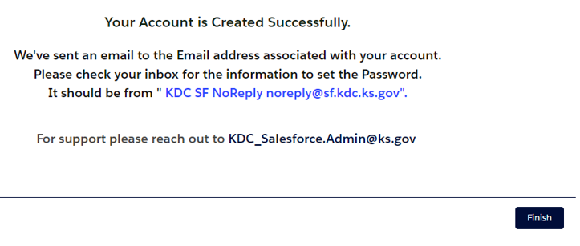
Step 6: Please check your E-Mail Inbox or Spam folder for an email that had an Email with a link from noreply@sf.kdc.ks.gov for setting up a password to your account.
Note: The link is valid only for 24 hours. If the link expires, then you can use the “Forgot Password” Feature from here . For any support please reach out to KDC_Salesforce.Admin@ks.gov.
After setting up the password then you can log in with your Username and Password.
After Successful login, you can see the screen as shown below.
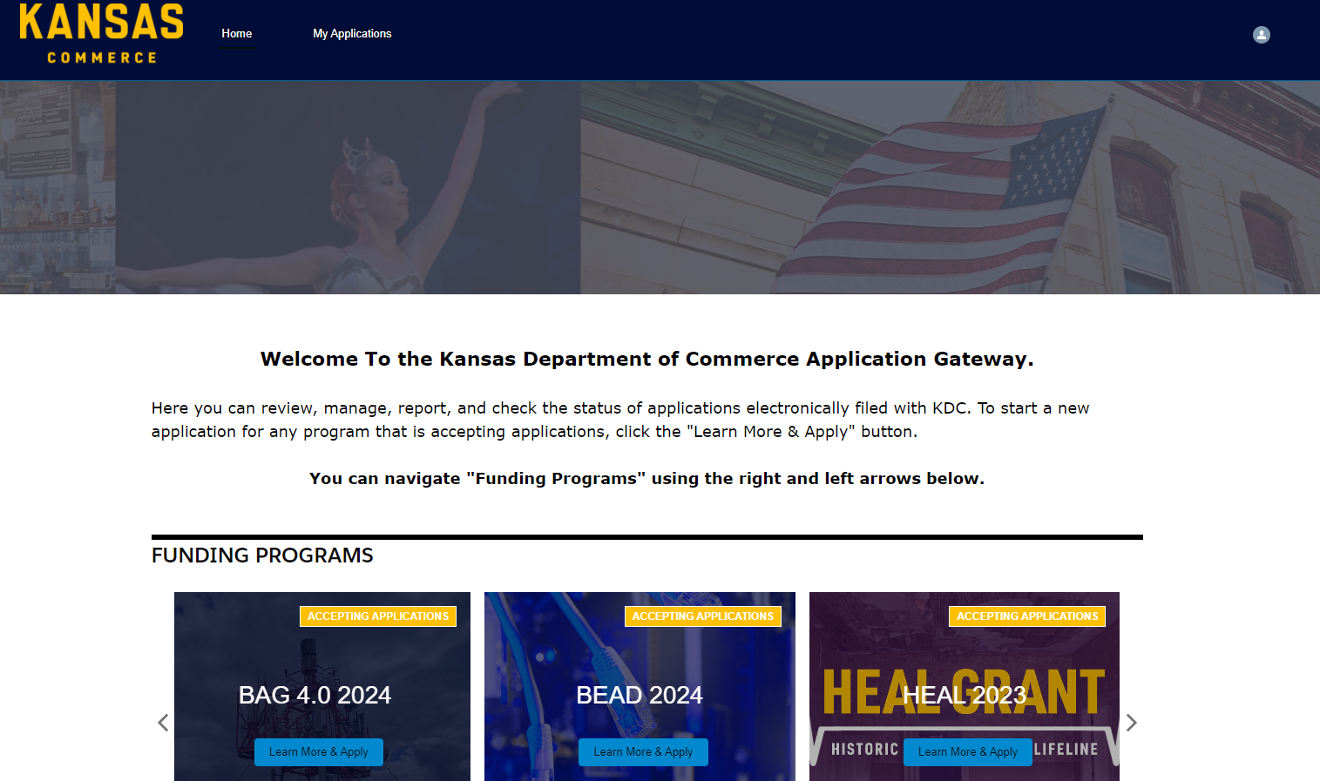

PERFECT!!!!! REGISTRATION SUCCESSFUL!!!!!

After Successful Registration on behalf of – Business
- Note: After successfully registering on behalf of a business, it is mandatory to get associated with the working account. This would be a one-time process and follow the steps below to get associated.

- Go to https://kansascommerce.my.site.com/Grants/s/ and log in using your Username and password.
When you scroll down you will see Program Forms, under that you will have two options:
- Add Account Relationship:
- If you signed in on behalf of a business, then you must fill out the Add Account Relationship Form.
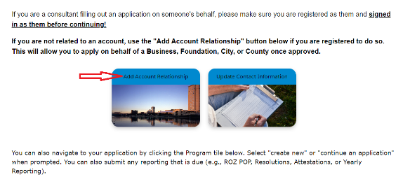
- After clicking on Add Account Relationship, if you have any pending requests, please try to fill out the form, and submit it under Continue Account Relationship. Otherwise, click on Add Account Relationship to create a new one.
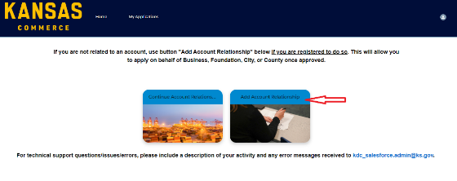
- If you go to Add Account Relationship, then the page looks like as shown below with the Create Account Relationship button.
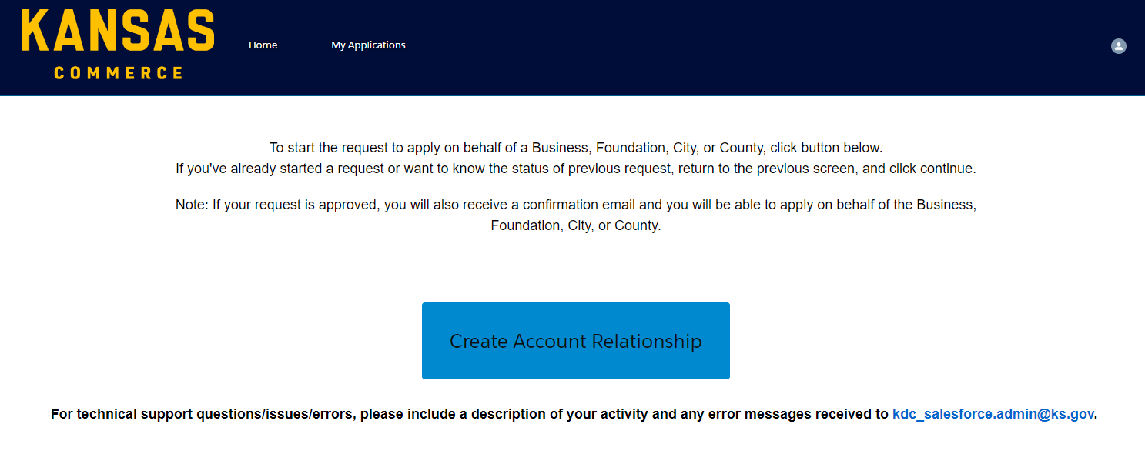
- After going to the Create Account relationship, you must fill in the required information like Account Name, Account Type (County, Foundation, City, or Business), and Commerce Program (the program you want to apply).
- Click Next.
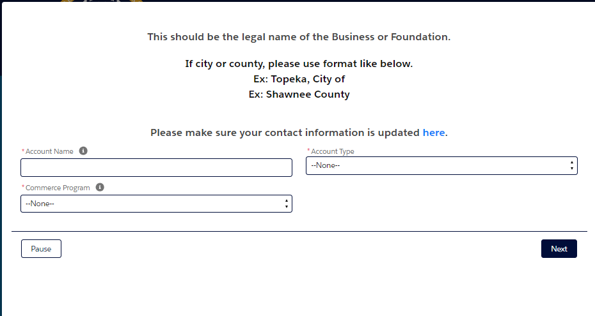
-To continue the request on behalf of a Business, Foundation, City, or County, click on Continue Account Relationship Request as shown below.
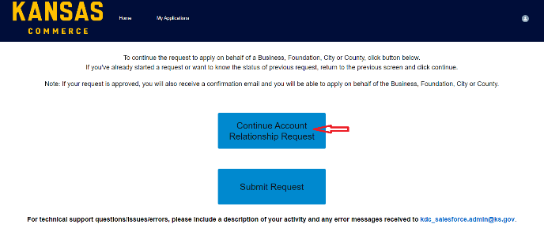

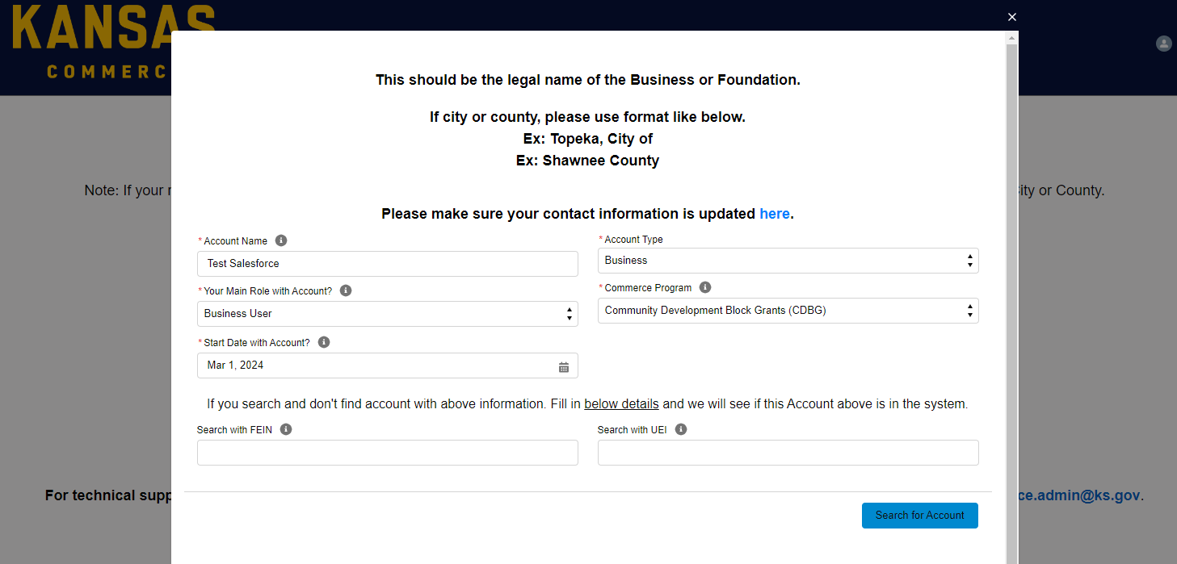
- After clicking on Continue Account Relationship Request, please fill out all the details and click on Search for Account on the next page click drop-down Select Account and see if the account on which you are applying appears in it,
- If shown in drop-down select the account and click Continue, else click Continue.
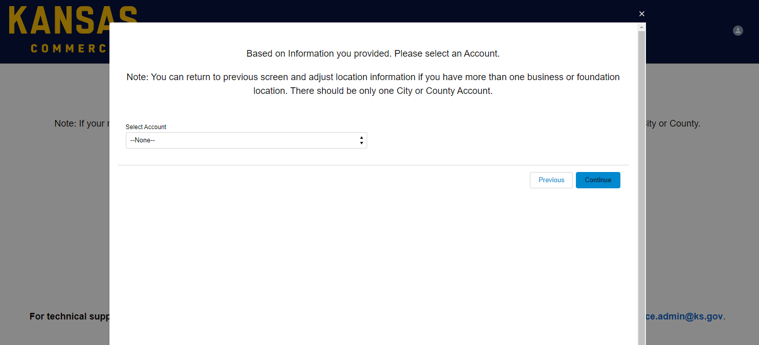
On the next screen please fill all the details to add or create your business record in our system. Once all the details are entered, please click on the “Submit Section & Create Account” Button.
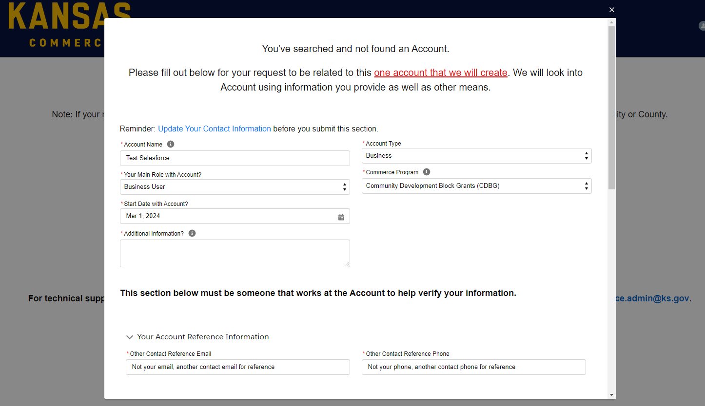
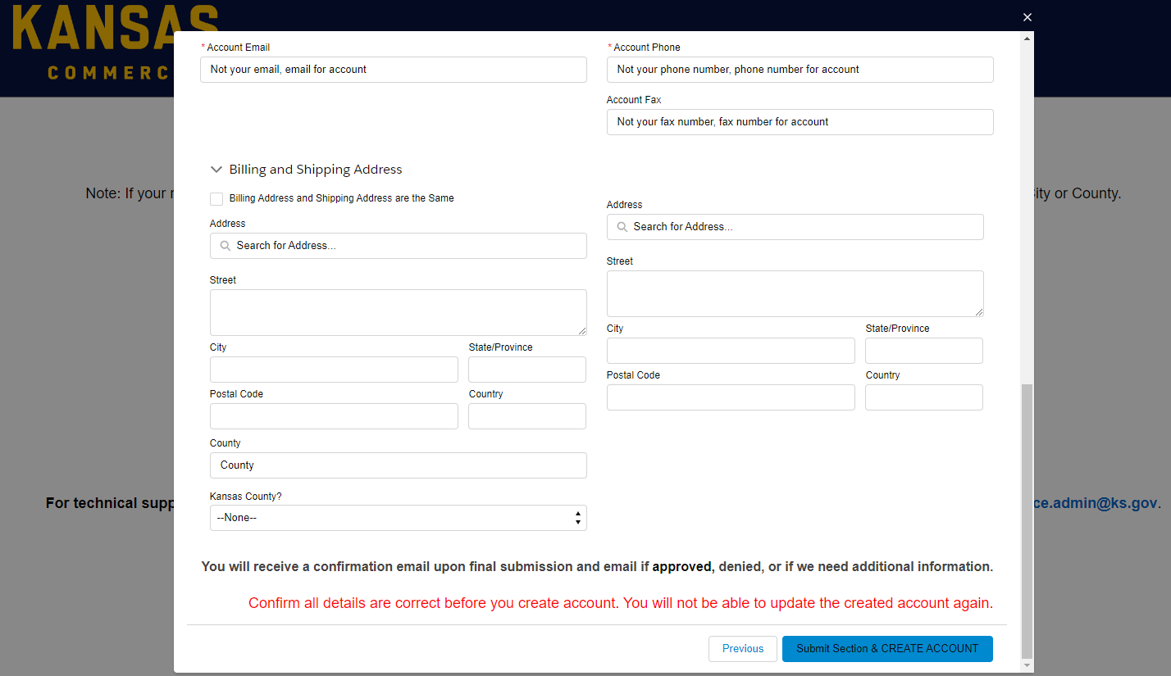
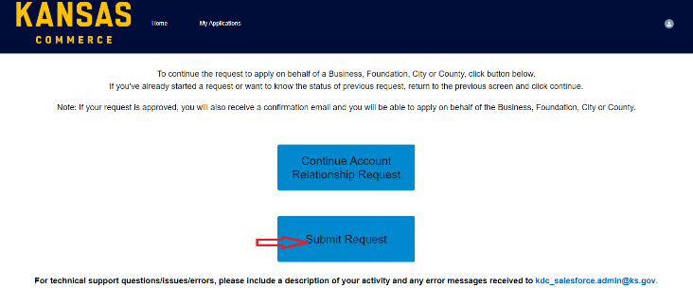
If your request is approved, you will receive an email then you can come back to the portal and apply for the program.
- If you are already done with submitting all the information which are required, then you can click Submit Request.

- Update Contact Information:
- After filling out all the information, you feel something to change or update about your contact information. It refers to the Personal Contact information or Business Contact Information. Click Update Contact Information to change the details.
- Fill in all the required details which you must change then click on Submit Update.
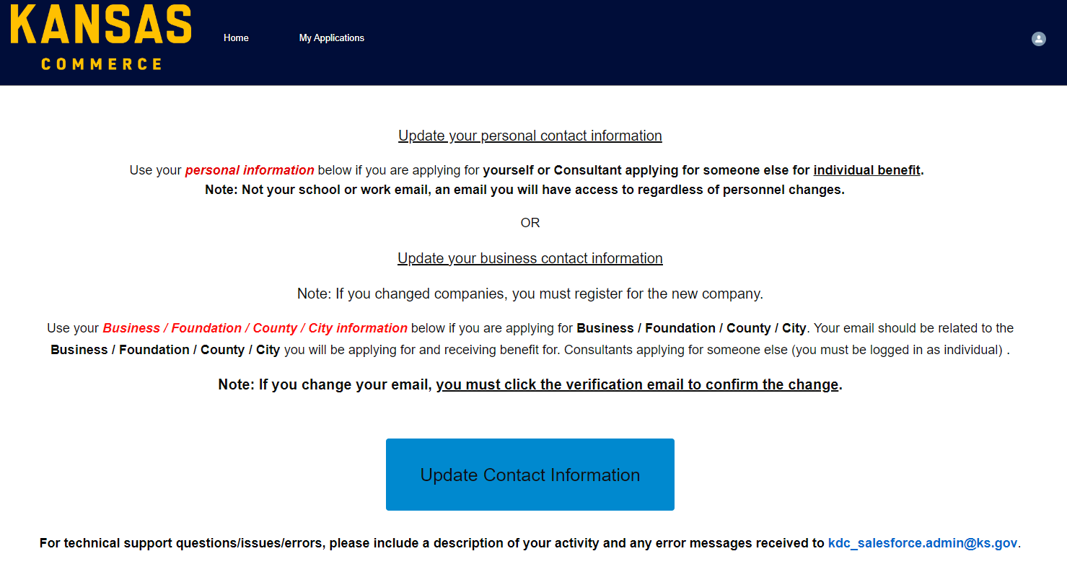
Note:
- Want to access the personal information, must has to login with your personal E-mail not your Work or School E-mail.
- If you changed companies, must register for the new company.
- If you change your E-mail address, must click the verification email to confirm the change.

For any technical support questions/errors/issues, please include a description of your activity and any error messages received to kdc_salesforce.admin@ks.gov.

